Hypnosis in Neurowarfare
by Michael McCarron
[rough draft, 9/10/2020]
https://github.com/autonomous019/Artificial-Intelligence-Research

Is Torture Hypnosis? It’s an interesting question to consider while we may view the process of hypnotism as a non-invasive parlor game, the reality is that in interrogation in the military intelligence world ‘pressure’ or ‘torture’ is used to induce a suggestive state in interrogates. This is partly what led to the treatment of POW’s during America’s two Gulf wars as ‘terrorists’, although these methodologies were learned by the US from the UK. Little is known in the US or UK about the original hooded men of the Irish in Northern Ireland as recounted by the US DIA in 1972:
July 1972
Section II - Current Events
Part A - Events in Northern Ireland
1. (U) The following discussion is based on 1971 and 1972 literature dealing with the manipulation of human behavior. The events that have been reported to have occurred are not Soviet originated but provide an excellent example of the type of efforts that this report is expressing.
2. (U) Recently there has appeared in the press some discussion elaborating on the techniques and procedures for detaining, treating and interrogating prisoners in Northern Ireland (2,3). According to the report, once the detainees are in prison, they come under three types of regime which create in men a state of great confusion, suggestibility, and distress. The first regime contained various methods to produce sensory isolation. The men were made to stand still against a wall with their hands in the air for four to six hours at a time. The total length was 43 1/2 hours. Hoods were placed over the men's heads to further abolish visual input. Sensory input was further decreased by having loud noise generators turned on in order to mask meaningful sounds. The detainees were, therefore, isolated from their sensory world.
3. (U) The second sensory regime has the effect of increasing confusion and disorientation. Some men were rushed out, hooded and doubled up, past barking dogs, loaded into a helicopter, doors closed, engine revved up, then unloaded, then reloaded, with the procedure repeated three times. In another incident, detainees without shoes were made to move quickly over rough ground by military police.
4. (U) The third type of treatment has the effect of increasing stress and anxiety and reducing resistance to the disorienting effect on the two types described above. It appears the dietary intake was restricted to bread and water at six hour intervals. Maximum weight loss was achieved it appears. ONe detainee lost eight pounds in seven days. To accompany the diet restrictions, no sleep was allowed the first two or three days. Forty-eight hours sleep deprivation, in certain individuals, has been known to precipitate psychotic-like states.
5. (U) Psychological torture and physical abuse has been used on Catholic detainees in Northern Ireland. High-frequency sound waves (range not give in report) and sensory deprivation - research methods that have been outlawed for use on humans by the American Psychological Association - were being used to undermine the dignity and destroy the effectiveness of the Catholic minority in Northern Ireland. The case of one 40-year old released prisoner has been reported. Upon release, the man's mental and physical condition suggested senility - a condition inconsistent with his health at the time of his internment. The man walks like he is 65, whimpers in the dark and has an attention span so short he cannot carry on a conversation.
6. (U) The Northern Ireland procedure can be expected to greatly increase the pliability of detainees under interrogation since sensory deprivation increases suggestibility and lowers intellectual competence. Stress-isolation techniques can reach the extend of eliciting false confessions where both prisoner and interrogator are convinced the statement rendered are true. It is hoped that the above examples impart to the reader a feeling for the type of mind manipulating procedures that will be discussed later in this report.
7. (U) since it appears that the research behind sensory deprivation has been put to current use on humans, the interested reader might peruse Biderman and Zimmer's 1961 publication entitled "The Manipulation of Human Behavior" (4). The book represents a critical examination of some of the conjectures about the application of scientific knowledge to manipulation of human behavior. The problem is explored within a particular reference: the interrogation of unwilling subject. Attention has been focused on interrogation because of the central position this topic has had in public discussions of prisoner of war (PW) behavior. (DIA, 1972, 2-3)
As one can see from the report above the purpose of ‘pressure’ is to increase suggestibility. Which is to say hypnotic suggestibility, which sometimes can just lead one to free one’s conscience into a fake world where one will even confess to absolute delusions. A warfighter is going to want to understand how susceptible one is to hypnosis, not just to counteract the rare instances of being a POW but also to counter information or perception management attempts of the enemy at all times in all circumstances. In the following study I will be examining the issue of hypnosis from a physiological perspective identifying differences based in biology between biologically stratifiable individuals in terms of hypnosis.

Introduction to Hypnosis

What is hypnosis academically speaking:
Hypnosis can be defined as ‘‘a procedure during which a health professional or researcher suggests that a patient or subject experience changes in sensations, perceptions, thoughts, or behavior’’ [60]. Hypnosis is seen as a state of focused attention involving focal concentration, and inner absorption with a relative suspension of peripheral awareness and has three components [56]:
• absorption: tendency to become fully involved in a perceptual, imaginative, or ideational experience;
• dissociation: mental separation of components of experience that would ordinarily be processed together;
• suggestibility: responsiveness to social cues, leading to an enhanced tendency to comply with hypnotic instructions, representing a suspension of critical judgment.
We have shown that subjects in a hypnotic state reported a phenomenology of an altered state of consciousness: participants reported a higher degree of absorption and dissociation as compared to normal wakefulness and control conditions [12]. Other studies have also shown that hypnosis produces alterations in aspects of consciousness and is characterized by modulation of properties of the phenomenal self-consciousness such as mental ease (i.e. easy flow of thoughts), absorption, reduction in self-orientation and automaticity (i.e. responses are experienced as being produced without deliberation and/or effort) [47]. (Vanhaudenhuyse et al, 2013, 344)

There is a differentiation between Highly Hypnotizable and Low Hypnotizables:

By studying coherence of the EEG signal, Kirenskayaet al. [33] showed that baseline EEG differed in coherence between subjects with high and low hypnotizability. Indeed, highly hypnotizable subjects were characterized by higher distributed brain regions coherence within delta, theta, and alpha bands. A study conducted by Hinterberger et al. [25] showed the different states of consciousness that can be observed during a complete hypnotic procedure (relaxation-induction-suggestion-waking up) in one highly hypnotizable subject. The dominant pattern highlighted in this study can be summarized as follows:
• closed-eyes condition may be associated with increased bilateral parietal and occipital alpha, parietal sensory-motor and beta activities;
• hypnotic state seems characterized by increased frontal alpha, decreased central, frontal and parietal gamma bilaterally and increased occipital gamma;
• deep hypnotic state is characterized by distributed reinforcement of activity in all frequency bands;
• the awake state showed reduced activity on all frequency bands in central, frontal and parietal areas, while gamma increased in temporal and prefrontal areas (this last pattern is attributed by the authors to a highly relaxed but mindful wake state). (Vanhaudenhuyse et al, 2013, 346)
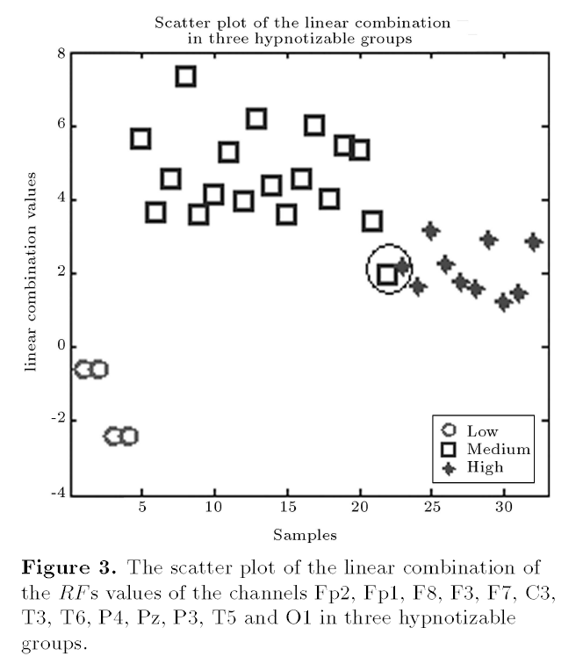
(Baghdadi, 2005, 77)

Brain mechanisms underlying the modulation of pain perception under hypnotic condition have been investigated by a growing number of neuro imaging studies. In PET studies, the modulatory effect of hypnosis was shown to be mediated by the anterior cingulate cortex (ACC) [17,48,50,49].In addition, studies have demonstrated increased modulation of the ACC and a large cortical and subcortical network, encompassing prefrontal, insular, and pregenual cortices, pre-SMA, thalami, striatum and brainstem in the context of hypnosis [17,18,48,50,49]. In an fMRI study, painful stimulation in a normal alert state resulted in brain activation within a network encompassing cortical and subcortical brain areas (i.e. ACC, premotor, dorsolateral, prefrontal, primary somatosensory and bilateral insular cortices, thalamus, bilateral striatum and brainstem) while the same stimuli perceived under hypnosis failed to elicit any cerebral activation [63]. We also demonstrated a hypnosis-related increase in functional connectivity between primary somatosensory cortex (S1) and anterior insular and pre-frontal cortices [63]. These results are not limited to healthy volunteers but are also observed in pathological states, such as patients suffering from fibromyalgia or chronic pain(Table 3). In a combined EEG and fMRI study, Rainville et al.[49] reported a reduction of the hypnosis-related increases in occipital and delta activity when subjects were painfully stimulated.
According to theories of hypnosis, one characteristic of hypnotic procedures is the inhibition of afferent nociceptive [pain sensing] transmission. This inhibition can be explained by the dramatically decreased activity in the thalamus that is observed under hypnosis [18]. The thalamus has also been shown to correlate with pain perception threshold while activation of the midline area (i.e. posterior cingulate cortex) correlates with intensity of the stimulation and ACC with unpleasantness of the stimulation [61]. It has been proposed that the reported increased functional connectivity between mid-cingulate cortex, thalamus and brainstem might be related to pain-relevant arousal or attention mechanisms [32,50].These observations can lead to the hypothesis that hypnosis involves subcortical gating processes on cortical activation that underlies the decreased subjective pain perception reported by subjects under hypnosis. The basal ganglia are known to encode and initiate basic movement patterns expressed through premotor pathways and have also been proposed to support basic attentional mechanisms facilitating the calling up of motor programs and thoughts [18,63]. In accordance with the reported decreases in premotor cortex activation in hypnosis, results of the different studies suggest that hypnosis may diminish anxiety, defensive and emotional reactions to pain by reducing activation of both cortical and subcortical areas [16]. The increased modulation of insular activity is in line with role of this structure in pain affect and pain intensity coding [49]. Modulation of frontal area activity may reflect disruption in cognitive attentional, appraisal and memory systems that can influence perception of environmental stimulation during hypnosis [18,63]. Finally, ACC is a brain area reported in several studies on executive attention, detection of errors, monitoring of conflict between competing cognitive processes and was shown to correlate with the difficulty of the task performed as well as with relaxation state of subjects [50]. Rainville et al. [50] proposed that engagement of the cognitive and neurophysiologic processes implied in each of those accounts may be accompanied by subjective experience of increased mental absorption as reported by subjects under hypnosis. In addition, ACC has also been considered to be involved in the ‘‘suffering’’ component of pain and affective reactions associated with pain unpleasantness [65]. Its decreased activity during hypnosis reflects the decreased unpleasantness of the stimulation reported by subjects under hypnosis. Finally, the observed reduction in occipital and delta activity during painful stimulation was proposed to reflect disruption of relaxation and/or imagery processes by pain during hypnosis [49]. (Vanhaudenhuyse et al, 2013, 347)

We see in the previous that there are differences during hypnosis in brain waves. As well as some of the brain functions involved in hypnosis. There are identifiable elements based on physiological profiles or models that can explain the stratification in hypnosis which is known as ‘highly hypnotizable’ and ‘low hypnotizables’ as well as a mid-range which comprises of 60% of any given population, whereas highs are 30% of any given population and lows are 10% of any given population. The Brain patterns associated with Highs primarily engage the brain patterns associated with imagery in the visual cortex, whereas lows, are cognitively engaged with associated cognitive brain activity (Baghdada & Nasrabadi, 2010, 72). This has been explained to a certain extent according to researchers with rostrum size in the corpus collosum, which is involved in allocation of attention and transfer of information between prefrontal cortices, on the other hand low hypnotizables have a normal sized rostrum. The hypnotic process is not uniform but changes over a hypnotic session through time, "as one progresses through hypnosis, the altered consciousness deepens with time. The deepest hypnotic state is at the latter parts of a hypnotic session” (Baghdadi & Nasrabadi, 2010, 77).
Other researchers have found physiological stratification in Low and High based in the construction of the ACC, specifically the dACC, key to monitoring conflict in neural nets fMRI measured higher signals in ACC during conflict. Where in High Hypnotizables dACC (dorsal ACC) activation is higher then Low Hypnotizables.

Recently, we used hypnotic suggestion as an attentional tool to manipulate conflict (16). Whereas earlier case reports (17, 18) and at least one esoteric study (19) reported promising preliminary findings by using hypnotic suggestions, we used an experimental design using a posthypnotic suggestion, a condition wherein a subject complies with a suggestion made during the hypnotic episode after termination of the hypnotic experience (16). Although subjects may not remember being told to adhere to a specific instruction, the posthypnotic suggestion is usually summoned on a prearranged signal and can be effective in highly hypnotizable individuals (16, 20–23). Posthypnotic suggestions, therefore, unlike hypnotic suggestions, take effect in a conventionally behaving person during common wakefulness (16). Earlier, we used this system in a laboratory setting and presented behavioral findings showing elimination of Stroop interference (20). We then replicated our results by using appropriate control for visual accommodation as well as eye movements (21). Together with other findings (24), these data led us to conclude that a top-down neural process, rather than optical degradation of the input stimuli, is responsible for this effect (25). (Raz et al, 2005, 9978)

Investigating the Stroop conflict by using fMRI, we compared brain activity with and without posthypnotic suggestion at the ACC both between and within groups. Fig. 1A shows significant interaction between group (highly vs. less-hypnotizable persons) and suggestion (absent vs. present) for Stroop conflict (see also Table 3). Further comparisons revealed that whereas for the less-suggestible controls ACC activation was not reduced upon suggestion, within the highly hypnotizable group, suggestion elicited a significant reduction in ACC activation (see the ACC in Fig. 1 B and C). In fact, although fMRI data from less suggestible individuals showed a significant increase in activation on incongruent trials, no difference in brain activity between congruent and incongruent trials appeared in highly hypnotizable persons given the posthypnotic suggestion (Fig. 1C). In addition to ACC activity reduction, we found fMRI signal reduction in posterior brain activity within an extrastriate visual area (Fig. 1A). (Raz et al, 2005, 9980)

Raz et al has studied the difference between lows and highs, lower pain induction gives lower activity in ACC lower activity in somatasensory cortex "suggestion wields a general dampening down effect on early visual acitivity" (Raz et al, 2005, 9982)

Positron emission tomography assays of pain show that specific modulatory hypnotic suggestions affect activation of different brain structures: whereas suggesting a drop in pain unpleasantness reduces specific activity in ACC (31), suggesting decreased pain intensity produces activity reduction in somatosensory cortex (32). A recent fMRI study extended these findings to illuminate the role of placebo in the context of pain (33). These collective accounts underline the influence that attention and suggestion can impart to conflict situations, top-down cognitive organization, selfregulation, and effortful control (16, 34, 35). Consonant with reports showing left and right lateralization for orthographic and nonorthographic stimuli, respectively (36), our ERP data show that in the absence of suggestion (e.g., Fig. 2C at 179 msec), posterior brain activity was more left-lateralized (i.e., in line with orthography), whereas the presence of suggestion reversed this trend (e.g., Fig. 2C at 234 msec). Furthermore, the ERP findings show that suggestion likely influences attention-sensitive electrophysiological components (37). These results seem to indicate that suggestion wields a general dampening- down effect on early visual activity as indexed by electrophysiological components (i.e., P100 and N100), showing both a shift and a reduction in amplitude. Representative snapshots, captured from a time-course video showing cortical electrophysiological activity across the entire brain (Movie 1), illustrate these effects at their respective peaks (Fig. 2C). Notably, whereas suggestion attenuated earlier components, the
P300 remained unaffected. Suggestion may instigate lowered visual system activation by reducing attention either to specific visual stimuli (e.g., words) or to the actual input stream (e.g., dampening down all visual stimuli). The paucity of fMRI signal differences between incongruent and congruent trials (Fig. 1C) together with the ERP data of the highly hypnotizable individuals under suggestion (Fig. 2) seem to support the latter possibility…. (e.g., overall performance of the highly suggestible participants was 100 msec faster than that of the less-suggestible persons) may be important to consider (39).

Our results show that in highly hypnotizable persons, a specific posthypnotic suggestion to construe Stroop words a nonsense strings reduced conflict, as indicated by both behavioral data and ACC activity reduction. Evidence of reduced ERP under suggestion proposes strong modulation of early occipital cortex activity. This altered visual processing probably affected downstream cognitive activity, including ACC activation. Our results highlight the role of posthypnotic suggestions in altering cognitive processes. This knowledge may pave the road toward illuminating the neural correlates of other suggestion-based interventions. For example, a greater importance has been placed recently on trying to understand the placebo effect (33). It is important to compare hypnotic suggestions with other methods for modulating cognitive control, including placebo. (Raz et al, 2005, 9982)

In a more penetrating study that goes into the various neural networks in the Brain that are affected by Hypnosis Jiang et al (2017) studied the interaction of the Default Mode Network, the Salience Network and Executive Control Network.

Functional Connectivity:
Executive Control Network ECN - focused attention, working memory tasks
Salience Network SN - activated during tasks, joins dACC, when one is challenged or anxious, can be used for contextual understanding, [see Tarashenko on ‘Salience detection’ in computer algorithms.]
Default Mode Network DMN - during rest and rumination and de-activated as task engagement increases.

High Hypnotizable. - decreased DMN Activity, increased connectivity of left anterior aspects of the DLPFC of the ECN and the dACC of the SN; higher levels of the dopamine matabolite homovanillic acid in the cerebral spinal fluid. (Jiang et al, 2017, 4084)
- dACC deactivation is task dependent, with decrements in activation related to decreased negative affect. dACC activation is associated with appraisal and expression of fear and pain (Etkin et al 2011), as well as a sense of personal agency or will to persevere.
- increased connectivity b/w ECN and SN gives amplified task related activity reflecting increases or decreases in anxiety (Jiang et al, 2017, 4084)

The Following Key Points in terms of Hypnosis and the Brain:
1. Hypnotic state in highs- decreased low freq. amplitude in dACC (only in Highs)
2. Hypnosis invokes a suspension of critical judgement and ability to immerse oneself in a task while reducing awareness of alternatives [good counter RC necessitates exploration and alternatives].
3. ACC associated with 'will to persevere' reducing ACC activity decreased personal agency and contribute to heightened suggestibility as well as the ability to dissociate from distress and pain that are characteristic of hypnosis.
4. Highs displayed increased connectivity b/w bilateral DLPFC and the ipsilateral insula during hypnosis (Highs Only) [An important function of the DLPFC is the executive functions, such as working memory, cognitive flexibility,[8] planning, inhibition, and abstract reasoning.[9] However, the DLPFC is not exclusively responsible for the executive functions. All complex mental activity requires the additional cortical and subcortical circuits with which the DLPFC is connected.[10] The DLPFC is also the highest cortical area that is involved in motor planning, organization and regulation.[10] ]
- insula: processing body control and experience, emotion, empathy and time, spatial temporal aspects of pain control and empathy with others pain.
- sham mobile phone radiation in electrosensitive subjects caused somatic symptoms that were mediated through increased insular activity (Langrebe 2008), (Jiang et al, 2017, 4089)
- Insula self-reflection, self-monitoring, self-regulation which are all thought processes that can be altered in hypnosis [In RC change the image of self] and in related dissociative states involving alterations in identity, memory and consciousness.
5. reduced connectivity between left DLPFC and PCC was notable during hypnosis in highs but not during memory, and it was the clearest state difference highlighting hypnosis. These DMN regions are involved in self-referential processing and episodic memory (Greicius and Menon 2004), while the ECN is involved in cognitive control (Seeley et al. 2007), and the two networks become anticorrelated during working memory tasks (Leech et al. 2011). Dissociation between ECN and DMN in response to hypnotic induction likely reflects engagement in the hypnotic state and associated detachment from internal mental processes such as mind wandering and self-reflection.
6. Taken together, our findings indicate that cross-network coactivation patterns are modulated by hypnosis. Decreased fALFF in the dACC may reflect reduced context comparison and decreased attention to the external environment, while at the same time connectivity between the DLFPC and the insula is up-regulated, which facilitates somatic surveillance. Further, the decoupling of the DLPFC from the DMN during hypnosis reveals another neural mechanism underlying hypnotic absorption and, potentially, hypnotic loss of self-consciousness and amnesia (Kihlstrom 2013).

Increased theta activity occurred within the left fusiform gyrus, insula, and middle temporal gyrus and within both the left and right parahippocampal gyrus. Higher (alpha) frequencies were evident within anterior cingulate gyrus and the superior and middle temporal lobes for both hemispheres for those subjects whose scores for congruency between drawings and descriptions and the hidden pictures were most accurate. Examples of the most robust and reliable change in s_LORETA profiles between the first and third sessions are shown in Figures 5 through 7. These data suggest that accuracy of experiences about a distant stimulus are related to brain regions whose functions involve spatial localization, emotional attachment and bonding, and visuolinguistic memory and processing. (Persinger, 2013, 386)

-----------------------------

Partial Epilepsy and Strobe Effect related:

In our opinion, from the perspective of treatment, the most important observation was the increased power in the delta range within the medial frontal and anterior cingulate region as inferred by sLORETA when the pinwheel was moving as verified by an external observer in her vicinity. Although increased activity in the latter region, particular the right anterior insula is associated with disembodied hallucinatory voices (Craig, 2009; Sommer et al., 2008) and auditory hallucinations (Szechtman, Woody, Bowers, & Nahmias, 1998), which Ms. S experienced and attributed to her invisible friends, the involvement of the prefrontal region suggests organization, intent, and an awareness that some process was occurring. This was reflected in her reports that ‘something’ was about to happen in a manner similar to a preictal state. The antecedents of these experiences are likely to have occurred within the right temporal lobe for two reasons. First, there was a marked increased coherence within the 6–7-Hz band between the two regions in the temporal lobes, one of which was near the source of the chronic anomaly. Secondly, she responded with intense sadness and emotion, very similar to what happens after the ‘spontaneous’ display of these experiences, when she was exposed without her knowledge to a 7-Hz amplitude modulated experimental magnetic field with intensities similar to those associated with increased geomagnetic activity. Her profile was similar to people who are easily entrainment by weak applied, physiologically patterned magnetic fields (Persinger et al., 2009). In fact her presentation clinically was quintessentially representative of Bear’s (1979) temporal lobe syndrome of sensory-limbic hyperconnectionism that is frequently seen in subclinical (Persinger & Makarec, 1993) and clinical (Bear & Fedio, 1977) complex partial epileptic patients with foci within right temporal lobe (Bancaud, Brunet-Bourgin, Chauvel, & Halgren, 1994).

In our experience, many patients with closed head injuries have reported sensitivity to weak magnetic fields. We have shown this effect with single cases (Persinger et al., 2009). Subsequent analyses of Ms. S.’s reports for weeks after she left the laboratory showed that the report of the unusual experiences occurred during the 10-minute period after increases greater than approximately 25 nT intensity in geomagnetic activity. A similar threshold has been reported for report of bereavement apparitions (Persinger, 1988) and for vestibular experiences during partial sensory deprivation in the
normal population (Persinger & Richards, 1995). Our (Saroka & Persinger, 2011) experiments with other forms of cerebrally applied magnetic fields may help explain why the rotation of the pinwheel diminished [also see strobe effect] when she listened through earphones to music. Many of these small solenoids (of the earphones) applied upon the ears, which are immediately adjacent to the temporal lobes, can generate magnetic field energy levels that are equivalent to the mechanical patterns that generate sound. Whether or not this strategy could be used therapeutically to control unwanted experiences remains to be established. We have counseled patients, who experience terrifying nocturnal sensed presences subsequent to closed head injuries, to quickly activate an acoustic source and to listen to music containing lyrics. This simple temporal lobe stimulation eliminates the experience of a sensed presence. (Persinger & Roll, 2012)

-----------------------------
For example, Berns et al. (1997) showed that small changes in the grammatical structure during reading that were not perceived by participants produced conspicuous local changes in discrete subsurface structures such as the anterior cingulate that is associated with emotional bonding and affect. Hoshiyama et al. (2003) demonstrated ‘‘subconscious’’ responses within the right hemisphere during the presentation of facial patterns even when the stimuli were presented for ‘‘subliminal’’ durations or once every *2 s (0.5 Hz). In general, a ‘‘critical mass’’ and organization of neurons in the cerebral cortices is required for ‘‘awareness’’ (Fendrich et al. 1992). The brain affects all of the organs and tissue; cerebral changes, even without ‘‘awareness,’’ can determine adaptation. The non-specific experiences that include ‘‘ill feeling,’’ malaise, lethargy, low-level nausea, dizziness, mild
apprehension, and diminished ‘‘concentration’’ are often reported in the presence of infrasound with or without the ‘‘awareness’’ of its presence. (Persinger, 2013, 503)

Experiences of pain are also associated with altered activity in the anterior cingulate the same region that is associated with emotional bonding, the feeling of well being, and the cerebral responses to ‘‘unconscious’’ changes in the environment. (Persinger, 2013, 512)

------------------------------

Parasitic Consciousness-

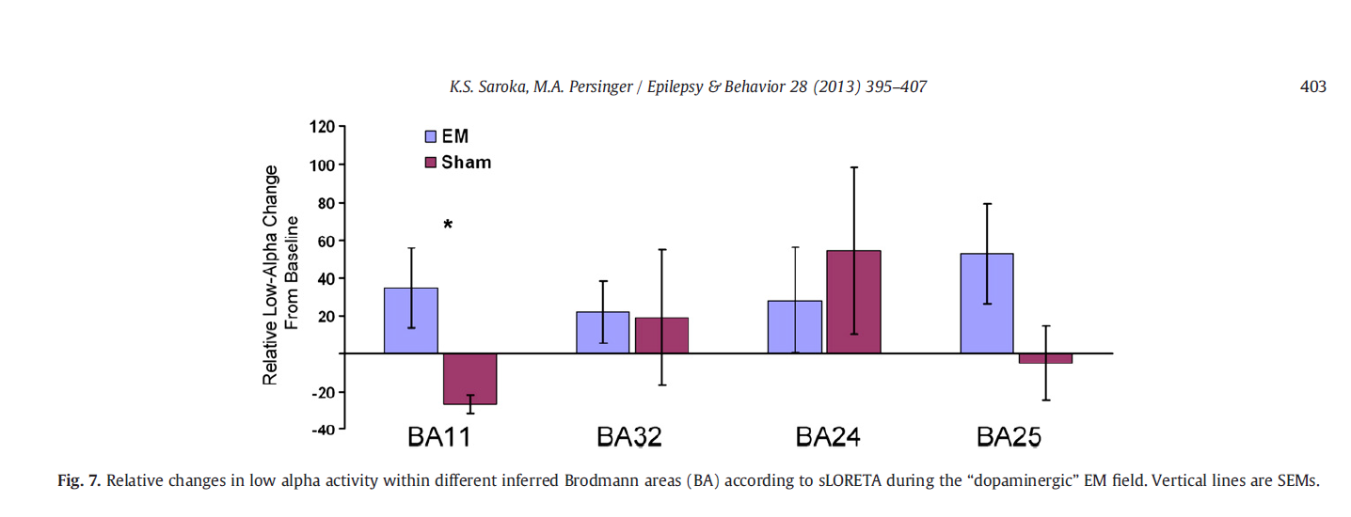
The “chill and tingling” response by a specific and new pattern of magnetic field was observed. The analysis demonstrated that those
who received the electromagnetic pattern designed to simulate “dopaminergic burst firing” reported significantly more tingles (F1,9 =
6.48; p b .05; eta2 = .42) than those exposed to the sham field. In fact, not a single participant in the sham condition reported this experience.
To discern whether the field or simply sitting in the chamber influenced activation of the brain in any systematic way, source localization was completed on the data extracted from each raw record. The analysis indicated that there was a significant decrease (p b .05) in delta (1.5–4 Hz) activity within the posterior cingulate and a region encompassing the medial frontal gyrus (BA 11), the dorsal and ventral regions of the anterior cingulate (BA 32 and 24), and the ventromedial prefrontal cortices (BA 25) for individuals who did not receive a magnetic field, i.e., the sham field condition (Fig. 6). These areas were identified as regions of interest (ROIs), and activations within these regions were extracted for further analysis. Relative scores frombaseline at 10, 20, and 30 min of field exposure were computed on the sLORETA activation scores pertaining to the above mentioned regions-of-interest. These scores were subsequently entered into separate multilevel analysis of variance with one between-subjects factor (condition) and 3 within-subject factors (time, region-of-interest, and hemisphere) for the delta (1.5–4 Hz), theta (4–7.5 Hz), low alpha (7.5–10.5 Hz), high alpha (10.5–13.5 Hz), low beta (13.5–20 Hz), high beta (20–30 Hz), and gamma (30–40 Hz) bands.

[
The Brodmann area 32, also known in the human brain as the dorsal anterior cingulate area 32, refers to a subdivision of the cytoarchitecturally defined cingulate cortex. In the human it forms an outer arc around the anterior cingulate gyrus. The cingulate sulcus defines approximately its inner boundary and the superior rostral sulcus (H) its ventral boundary; rostrally it extends almost to the margin of the frontal lobe. Cytoarchitecturally it is bounded internally by the ventral anterior cingulate area 24, externally by medial margins of the agranular frontal area 6, intermediate frontal area 8, granular frontal area 9, frontopolar area 10, and prefrontal area 11-1909. (Brodmann19-09).
The dorsal region of the anterior cingulate gyrus is associated with rational thought processes, most notably active during the Stroop task.
In the human this area is known as ventral anterior cingulate area 24, and it refers to a subdivision of the cytoarchitecturally defined cingulate cortex region of cerebral cortex (area cingularis anterior ventralis). It occupies most of the anterior cingulate gyrus in an arc around the genu of the corpus callosum. Its outer border corresponds approximately to the cingulate sulcus. Cytoarchitecturally it is bounded internally by the pregenual area 33, externally by the dorsal anterior cingulate area 32, and caudally by the ventral posterior cingulate area 23 and the dorsal posterior cingulate area 31.
Francis Crick, one of the co-discoverers of the structure of DNA, listed area 24 as the seat of free will because of its centrality in abulia and amotivational syndromes[citation needed].
]
The analysis demonstrated a significant condition by ROI interaction (F3,27 = 3.10; p b .05; partial eta2 = 26). Post hoc analyses utilizing four separate one-way analyses of variance indicated that Fig. 5. (Top) There was a statistically significant increase in gamma-band (>35 Hz) bilateral coherence approximately 10–15 minutes after the initiation of the Thomas pattern. (Bottom) The increase was accompanied by an increase in gamma power within the right prefrontal region as well as the anterior portions of the temporal lobe.
Fig. 6.
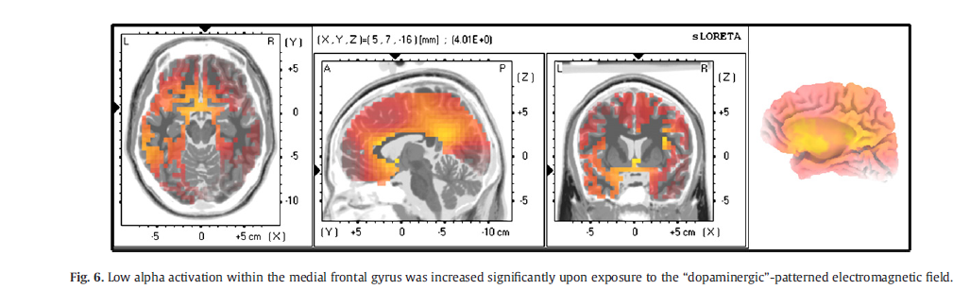

individuals exposed to the “chill-generating” magnetic field displayed statistically significantly higher (F1,9 = 6.75; p b .05; eta2 = .43) low alpha activation within the medial frontal gyrus (BA 11), whereas participants within the reference field condition showed a decrease
(Fig. 7).

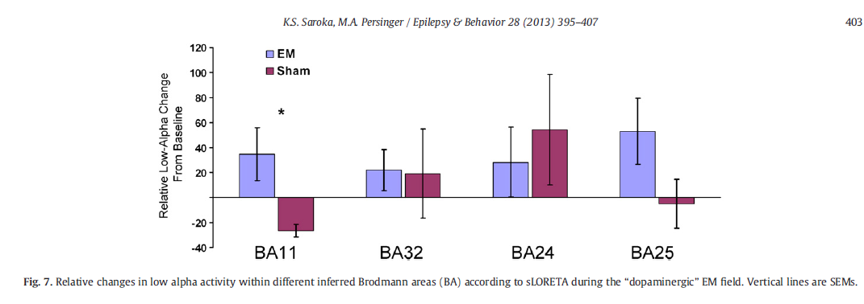

Because the current experiment did not allow us to assess brain activation at the exact time that the chill sensation was experienced, the relative scores at each time period were averaged together to produce a general activation score for each region-of-interest. Spearman rank-order correlations were then completed between these activation scores as well as the report of a tingly sensation. The analysis revealed that the experience of “vibrations” and “tingling” was positively correlated with activation scores within the medial frontal gyrus (rho = .81, p = .002) as well as the ventromedial prefrontal cortices (rho = .83, p = .002).

(Persinger, 2013b, 402-3)

Recent biomolecular studies [29] have shown that the same field patterns and intensities by which the sensed presence and out-of-body experiences are generated influenced T-type calcium channels and correlative changes in molecular pathways such as slowing of proliferation of cancer cells within cultures. (Persinger, 2013b, 396)
using waves to replicate pharmacological delivery of medicine or other drugs:
the term transcerebral stimulation (TCS) has been employed. We had reasoned that the more the complex pattern of the applied fields approached the form of intrinsic cerebral patterns, the less the intensity required to produce subjective and electroencephalographic changes. The rationale was similar to strategically developing molecular structures of pharmacological agents to be congruent with neurotransmitters for receptor subtypes. For analgesic effects in rats, for example, exposures of only 30 min to appropriately patterned magnetic fields with intensities of only 1 μT were equivalent to a subcutaneous injection of ~5 mg/kg of morphine [31] mediated through μ opioid receptors. (Persinger, 2013b, 396)
There is a loss of self due to cerebral injury (Persinger, 2013b, 396) [cerebral injury is a gateway to computer overtaking individual control]
moderately strong correlations between geomagnetic activity and right frontal lobe (Persinger, 2013b, 397) also note solar storms interfere with remote viewing
Identification of experiencing a sensed presence was correlated from 0.78 to 0.86 with increased power (μV2 /Hz) within the theta range over the right parietal and frontal regions [43]. (Persinger, 2013b, 397)
Increasing suggestibility:
In the St-Pierre and Persinger 2006 review, some of the experiments had involved groups who had been administered a norm-referenced interactive suggestibility scale (Hypnosis Induction Profile [see Baghdadi 2010 on EEG Profile of Hypnosis Induction replacing subjective tests]) developed by Spiegel and Spiegel [50]. Although some studies had shown that greater stimulation by these physiologically-patterned magnetic fields over the right hemisphere but not the left definitely increased suggestibility [51], this elevation was not associated with the occurrence of the sensed presence (Persinger, 2013b, 397)
In our studies, the magnetic fields were created by transforming a series of numbers, each between 0 and 256, to a voltage between −5 V and +5 V (127 = 0 V). The point or “pixel” duration was either 1 ms or 3 ms. This value is the duration of each voltage that composes the pattern…. Accurate and precise point durations are essential for producing the sensed presence [54,55]. Similar “temporal sensing” [rhythmic] sensitivity for cells has been shown for frequency-modulated weak magnetic fields [56]. (Persinger, 2013b, 397)
Designing an electromagnetic pattern that is compatible or “resonant” with the electrophysiological patterns of a “targeted” brain structure rather than attempting to “focus” a magnetic field is more feasible. Lagace et al. [63] demonstrated its effectiveness for the rat brain. (Persinger, 2013b, 398)

Gender Stratification in Suggestibility:
We [51] have found that the components of the sensed presence display gender-specific characteristics that are congruent with the general patterns of cerebral sexual dimorphism. On average, young women display a shorter latency to sense or report these experiences compared young men. (Persinger, 2013b, 398)
[investigate the effect on queer males, who typically have some female brain physiology, and lesbians who have some male brain physiology.]

The occurrence of these “spontaneous” experiences may be more prevalent than recognized [78,79]. Persinger and Koren [80] reported the case of a young woman who had a history of an early right prefrontal brain injury. She frequently experienced what she attributed to an “entity” that sexually stimulated her and appeared as an apparition. Most of the experiences, including the feeling of the outline of a “baby”, were over the left upper back of the body. Although the family preferred a more religious interpretation, the source of the stimulation was traced to a defective electronic clock that she placed near her skull when she slept. The clock generated a field with an almost identical complex temporal pattern and intensity as the frequency-modulated pulse employed in the laboratory that generated the effects in the present study (Persinger, 2013b, 405)
We suspect that there are many different neuroanatomical pathways and cortical configurations that would converge to produce the sensed presence, each with their own unique characteristics. The phenomena would be similar to the multitude of pathways that mediate the amnesic syndrome through the dorsal hippocampal commissure as described by Gloor et al. [73]. Considering the complexity of the human brain, one would expect that a multitude of cerebral cortical patterns whose net vectorial solution is similar could produce the sensed presence. This value can be obtained from a large number of combinations in a manner similar to Wackermann's [74] approach. As a group, the male participants from film crews over the years showed the enhancement during the second component of the presence protocol. The female participants showed more sensed presences during the first component. Over both components, there were equal numbers of sensed presences and out-of-body experiences for both the decreasing frequency-modulated and increasing frequency-modulated exposure components. We [51] have found that the components of the sensed presence display gender-specific characteristics that are congruent with the general patterns of cerebral sexual dimorphism. On average, young women display a shorter latency to sense or report these experiences compared young men. One explanation is that the parietotemporal regions of the average female brain display more EEG coherence than the average male brain [75]. Hence, the first field component with the enhanced right hemispheric stimulation would have increased the likelihood of the “intrusive” experience. For the men, the initial right hemispheric stimulation was required before the bilateral application could facilitate the interaction. (Persinger, 2013b, 404)

In addition to expectation factors, most of these participants in the film crew study were circadian-shifted or mildly sleep-deprived because of traveling. We have found that elevated “stress” as well as circadian shifts enhance the sensitivity and decrease the latency to respond to weak magnetic fields, assuming that they did not enter Stage 2 (“sleep spindles”) too quickly. If the subject “falls asleep”, there is no reporting. The neurochemistry associated with “stress”, particularly elevated corticotrophin releasing factor (CRF) and cortisol, seems to enhance the intensity of these experiences if they are occurring. (Persinger, 2013b, 405)

psychopharmacology. The mechanisms by which weak applied magnetic fields influence cerebral activity have shifted from Faradic induction and, hence, forces, to the concepts more compatible with quantum energy [76]. The increased energy “storage” [47,77] from an applied 10-mG (1 μT) magnetic field within the cerebral cortical volume would be in the order of 10⁻⁹ J. If each action potential is associated with energies of ~ 10⁻²⁰ J [76], then the applied energy would be equivalent to about 1010 neurons firing at about 10 Hz. This number of neurons is within the critical mass associated with “conscious awareness”. (Persinger, 2013b, 405)

Parahypocampal sensitive to EM fields in right hemisphere:
Mulligan et al. (2010) while replicating the innovative measurements of Babayev and Allahverdiyeva (2007), showed that quantitative shifts in gamma and theta activity over the right (frontal) hemisphere were strongly correlated with both geomagnetic activity and ionospheric power density. The sensitivity of the right hemisphere was demonstrated during whole body exposure to experimentally-generated, weak 7 to 8 Hz magnetic fields (Mulligan and Persinger, 2012). The stratum stellare of Stephan (Layer II) of the entorhinal cortices of the human parahippocampal gyrus contains star-shaped cells that are organized into small elevations (verrucae gyri hippocampi) on the cortical surface that can be recognized visually (Gloor, 1997) . These cells exhibit intrinsic oscillations within the 8 Hz range with amplitudes whose energies approach that associated with the loss or gain (Lindauer Threshold) of 1 bit of information. This is the fundamental frequency for the Schumann Resonance (7–8 Hz with increasing harmonics every ~6 Hz, i.e., 13–15 Hz, 19–21 Hz, 25–27 Hz) that is generated within the biosphere between the earth’s surface and ionosphere. (Persinger, 2013b, 3)

[Subject] ...exhibited persistent and conspicuous enhanced power in the low beta-range over the temporal lobes and specific changes in current source densities within the left inferior temporal gyrus and right parahippocampal region (Persinger, 2013b, 1)

For those patients who are actively experiencing, according to their verbal reports, inner voices application of these physiologically patterned fields with equal intensities across both temporal lobes markedly attenuates the numbers of “different voices” or eliminates their occurrence. Asymmetrical application with greater intensity over the right hemisphere enhances or initiates the experiences (Persinger, 2013b, 2)

The patient had some control over the occurrence of the intrusive voices, although at times they could occur spontaneously. When she “heard” these voices her verbal behaviour would become more monotonic (“machine-like”) and her pronoun usage shifted from “I” to “we”. QEEG indicated a persistent (measured on different days) 21–23 Hz higher amplitude (~70 μV) activity over T3 and T7 when she referred to “I” at which times she exhibited normal prosody. (Persinger, 2013b, 5)

When the “we state”[extrinsic influence] was reported there was marked fast, high amplitude 17–23 Hz activity from both T3 and T4 as shown in Figure 1. In addition she reported “transmissions” which usually involved more complex information from these voices as well as series of numbers. When this occurred there was a “normalization” of the EEG (Figure 2). When the “transmissions ended”, the unusual profile of T3 and T4 enhancements returned. There was additional similar activity over F7 and F8 which was transient. She was not talking during this period (after panel 1623). (Persinger, 2013b, 5)
During the experiences that would be classically labeled as “intrusions” the activation score for the low beta power within the right parahippocampal region more than doubled. This area and related hemispheric discrepancy are similar to that associated with “panics” that can occur suddenly in this group of patients. (Persinger, 2013b, 6)
Our interpretation is that the lowered base power within the delta range (upon which higher frequencies can be strongly dependent) within the left temporal lobe facilitates the conditions for inter-temporal lobe coherence and the experiences of “others” (Booth and Persinger, 2009). The enhancement of power within the left inferior frontal region, traditionally associated with expression of overt language (Petkov et al., 2009), could encourage the amplification of the person’s own array of “articulemes”. They are the neurocognitive patterns accompanying discrete neural activity that initiate sequences of stylopharyngeal and laryngeal muscle contractions. Anomalous organizations within the right prefrontal (Keenan et al., 2000) could increase the probability that the reconstruction of experiences would be attributed to non-self sources. (Persinger, 2013b, 6-7)

Political Brains

Physical Differentiation of Amygdala (Red) and ACC (Blue) between Red/Blue Polarities:
Brain Physiology of Liberalism:

Psychological differences between conservatives and liberals determined in this way map onto self-regulatory processes associated with conflict monitoring. Moreover, the amplitude of event-related potentials reflecting neural activity associated with conflict monitoring in the anterior cingulate cortex (ACC) is greater for liberals compared to conservatives [4]. Thus, stronger liberalism is associated with increased sensitivity to cues for altering a habitual response pattern [the opposite of effective RC] and with brain activity in anterior cingulate cortex. Here we explored this relationship further by examining whether political attitudes correlated not just with function but also with anatomical structure of these regions. To test the hypothesis that political liberalism (versus conservatism) is associated with differences in gray matter volume in anterior cingulate cortex, we recorded structural magnetic resonance imaging (MRI) scans from 90 healthy young adults (61% female) who self-reported their political attitudes confidentially on a five-point scale from ‘‘very liberal’’ to ‘‘very conservative’’ [3, 7]. We then used voxel-based morphometry (VBM) analyses [8] to investigate the relationship between these attitudes, expressed as a numeric score between one and five, and gray matter volume. We found that increased gray matter volume in the anterior cingulate cortex was significantly associated with liberalism (Figure 1A) (R = 22.71, T(88) = 2.633, p = 0.010 corrected; see Experimental Procedures for full details of analyses). We regressed out potential confounding variables of age and gender in our analysis (see Experimental Procedures). Therefore, our findings are not attributable to these factors. (Kanai, 2011)

Brain Physiology of Conservatism:
Conservatives respond to threatening situations with more aggression than do liberals [1] and are more sensitive to threatening facial expressions [5]. This heightened sensitivity to emotional faces suggests that individuals with conservative orientation might exhibit differences in brain structures associated with emotional processing such as the amygdala. Indeed, voting behavior is reflected in amygdala responses across cultures [6]. We therefore further investigated our structural MRI data to evaluate whether there was any relationship between gray matter volume of the amygdala and political attitudes. We found that increased gray matter volume in the right amygdala was significantly associated with conservatism (Kanai, 2011)

As we shall read later regarding Reflexive Control and other forms of biological influencing, in these findings Liberal structure is designed to break RC Control, whereas Conservative structure is designed to be controlled, as Fast Reflexion in RC Theory is facilitated by the Amygdala, it is a system based on manipulating the Fear responses of controlled subjects. Additionally, it is important to note how Fear/Anger is used in systems designed for military simulations such as Lockheed-Martin’s SCREAM platform, see Chapter ‘Lessons from an American Weapons Designer’. Hypnosis is involved in manipulating the ACC, but in the opposite manner as what is natural to Liberals, whereas liberalism would create more resistance to Hypnosis and Hypnotic suggestion the altering of the ACC by Hypnotism of Highly Hypnotizables would be in line with conservative physiology.

Another interesting note is that of the obesity epidemic that is affecting England and the United States (UKUSA) which roughly correlated to a problem with the Amygdala being hammered by constant EM fields in the last 4 decades or so, which is also when the obesity epedimic in these societies began, one could argue that with scientific experimental findings of Loscher et al (2003) and Persinger (2014) that there is a direct connection to obesity and the amygdala receiving excess EM waves and energy.

Excessive weight gains in female rats have been induced by extended kindling of the basolateral amygdala (Persinger 2014, fat rats study) cross correlate data on other amygdala references in paper.

Loscher et al:

Previous lesion studies have indicated a role of the amygdala in the central regulation of food intake. In the present experiments, twice-daily electrical stimulation of the basolateral nucleus of the amygdala in female Wistar rats was found to be associated with a significant body weight gain compared to unstimulated controls. On average, significant increases in body weight were observed after 25 amygdala stimulations, using a kindling paradigm for stimulation. Compared to kindled rats, in which amygdala stimulations were terminated after about 20 stimulations, extended kindling of the amygdala with up to 280 stimulations led to progressive weight increases and compulsive hyperphagia [over eating even when not hungry]…. The extensive weight gain over extended amygdala kindling provides an interesting new model for experimentally induced obesity. (Loscher et al, 2003)

[ The word kindling is a metaphor: the increase in response to small stimuli is similar to the way small burning twigs can produce a large fire.[3] It is used by scientists to study the effects of repeated seizures on the brain.[1] A seizure may increase the likelihood that more seizures will occur; an old saying in epilepsy research is "seizures beget seizures".[1]Repeated stimulation "lowers the threshold" for more seizures to occur. ]

Loscher here established that kindling, adding signals to the Amygdala, leads to obesity in mammals such as rats. Persinger (2014) has further studied this phenonomena and related it to energy being sent at the Amygdala:

Weekly (1.5 hr) exposures to physiologically-patterned magnetic fields over 36 wks had no effect on weight gain while continuous periseizure exposure to 50 Hz fields above about 1 μT facilitated mild weight gains and protracted aggression. Perinatal exposure to a very weak, a 7 Hz magnetic field or a nitric oxide inhibitor retarded the weight gain induced by the obesity procedure. These results indicate that synergisms during a single episode between neuronal electrical lability and pharmacological states can initiate a process of weight gain that progresses to extreme obesity. We suggest that at least a component of the global “epidemic of obesity” could be related to a synergism between the insidious emergence of amplitude modulations within biologically compatible electromagnetic frequencies from the proliferation of communication systems and the pervasive utilization of pharmacology to treat transient disorders of ontogeny within the human population. (Persinger, 2014)

Persinger notes that the most effect is in the basolateral amygdala which mediate specific Pavlovian-instrumental transfer, a phenomenon in which a classically conditioned stimulus modifies operant behavior.The primary function of the basolateral complex is stimulating fear response. The fear system is intended to avoid pain or injury. For this reason the responses must be quick, and reflex-like. To achieve this, the “low-road” or a bottom-up process is used to generate a response to stimuli that are potentially hazardous. The stimulus reaches the thalamus, and information is passed to the lateral nucleus, then the basolateral system, and immediately to the central nucleus where a response is then formed. There is no conscious cognition involved in these responses. Other non-threatening stimuli are processed via the “high road” or a top-down form of processing.[4] In this case, the stimulus input reaches the sensory cortex first, leading to more conscious involvement in the response. In immediately threatening situations, the fight-or-flight response is reflexive, and conscious thought processing doesn’t occur until later.

Persinger concludes his study with finding that suggests there is a direct correlation between weight gain, the amygdala and EM energy in the environment or directed at a subject:
Assuming complete penetrability of the skull, the energy within one typical neuron with a diameter of 10 micrometers would be within the range of a picoJoule per s. This is the same quantity of energy associated with
local (intracellular) glucose utilization. Whether or not such juxtaposition of electromagnetic sources and metabolic derivations of quantum energies would generate an emergent condition that would constitute the “limbic”
sensitivity of the type required to produce the insidious obesity measured reliably in our experiments requires
further study. However we suggest that the escalation of electromagnetic densities from Western civilization that
are now transglobal in nature is conspicuously coincident with the “epidemic” of obesity and the remarkably increased dependence upon pharmacological consumptions for a wide variety of normal challenges associated
with ontogeny. Although we do not have direct measurements for the entire population, our clinical experience
with a local sample indicates that the proportion of pre- and early post-adolescent females who have been prescribed psychotropic medications at least once exceeds at least about 25%. This value approaches the shift in the distributional curve towards larger body masses. (Persinger, 2014, 279-80)

Obesity and Election Maps from the USA
(elections red = conservative, blue= liberal)

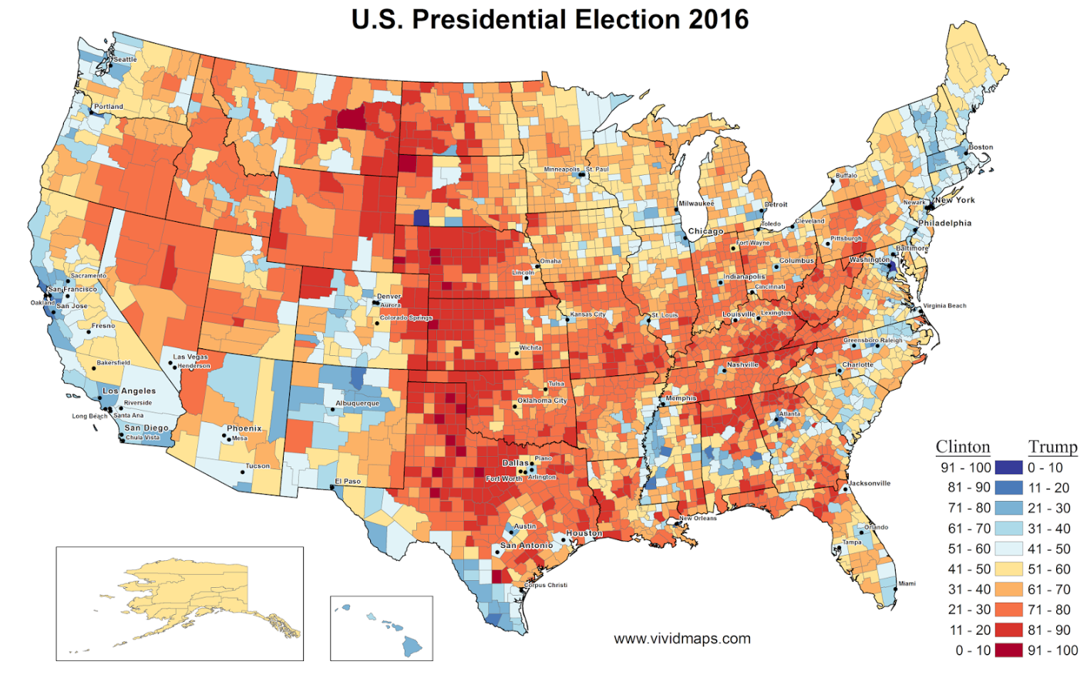
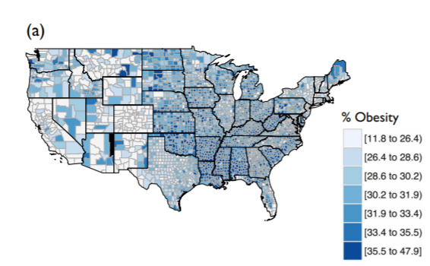

It is obvious that there is a broad and general correlation between conservative voting states and states with higher obesity. However, each state should be viewed on it’s own and analyzed at a much more granular level then these broad correlations, for instance Navajo areas have high obesity and diabetes due to non-Native diet, though largely liberal in political viewpoint. Each area has unique characteristics to be investigated further no single factor ever seems to convey anything too meaningful.

https://documents2.theblackvault.com/documents/cia/behavioral/C00021971.pdf
https://documents2.theblackvault.com/documents/cia/behavioral/C00022053.pdf

https://documents2.theblackvault.com/documents/cia/behavioral/behavioral-november2018.zip
https://documents2.theblackvault.com/documents/cia/mkultra/MKULTRA-Oct2018.zip

obesity map: https://www.nature.com/articles/s41599-018-0201-x
https://media.springernature.com/lw685/springer-static/image/art%3A10.1057%2Fs41599-018-0201-x/MediaObjects/41599_2018_201_Fig1_HTML.png

Operator, Operator
The staff of the Institute of Applied Psychophysics LLC has created a hardware and software complex, where the main receiving sensor for retrieving information from the research object is a human operator with an altered state of consciousness:
“The principle of operation of the apparatus is that the complex issues an information code (electromagnetic, radio and light pulses) for a specific effect on the operator's nervous system, introducing it into an increased susceptible state, thereby strengthening the biological connection between the operator and the object of study ... The design of the apparatus is lies the invention of V.I.Nesterova. The apparatus created by him is able to increase the sensitivity and increase the degree of reliability of the results of the operators' work by exposing the brain to a magnetic field by means of two magnetic inductors installed on the head, above the temporal regions, which generate the parameters of magnetic pulses of low-frequency oscillations with high-frequency modulation, close to theta, necessary for maximum effect -rhythms of the brain. (RF patent for "A method of increasing the reliability of biolocation studies", invention No. 2119806, priority from 21.08.96).
The imposed rhythms throw the biosystem out of balance, and the unbalanced system releases energy, i.e. there is an activation of the cerebral cortex, characterized by an increase in intuitive perception. "
There is also an additional means of influence:
“The laser emitter consists of a solid-state laser with a power of 5 mW and a wavelength of 630–680 nm. The laser beam is directed symmetrically relative to the eyes at a distance of no more than 15 cm from the bridge of the nose and 1 cm above it. The use of a laser is due to its use as a destroyer of a mechanical system. At the same time, a small energy of destruction is released, synchronized with the theta rhythm of the operator, which is expressed by an additional increase in the effect of intuitive perception ...
The information obtained is processed in a computer using programs created on the basis of theoretical and experimental research carried out by the researchers of the Institute of Industrial Problems "and is recorded" on the computer screen, where a virtual model of the organ is created in certain colors "(53).
The publication contains images of diseased organs obtained on a hardware-software complex - a cross section of the abdominal cavity, an image of the liver, etc.
It is clear how magnetic impulses increase the operator's sensitivity, it can be assumed that the laser beam is used to destroy the barrier between consciousness and subconsciousness to provide access to the information received by him. It remained unclear how it is removed from the operator himself. Most likely, through biologically active points.
The second part of the book will describe a strange borderline state between sleep and wakefulness, in which a person finds himself during the removal from his memory of large masses of information long forgotten by him, fragments of which, to control the reliability, sometimes, in rare moments of "enlightenment" and him.
The main question is: where do the “operators” come from, who agree to periodically expose their own brain to “low energy of destruction” to put it into a stressful state, do they know at all what they are involved in?
There is not the slightest confidence in the current Russian psychiatry, a worsened version of Soviet psychiatry, the deeds of these people are too black. But it is interesting to turn a living human brain into a part of a machine; this, you see, is completely original, and therefore interesting.
(Kravkov, 2006)

Phases of Controlled Subject:
In the extreme case (an experiment in the city of Dolgoprudny in January 2002), the controller, with the help of his equipment, sees the world through the eyes of the controlled, hears his ears, controls partly his movements, consciousness and speech directly, in real time. Previously, the subject was alternately subjected to mental pumping, fear pumping, radiation pressure for 24 hours, and was deprived of sleep on the night before the experiment, thus suppressing the will to resist.
As a result, the controlled (a person who was openly used as an experimental for 15 years), fully and accurately performed within an hour and a half, in the presence of third parties who did not participate in the control, but who knew the program of the experiment, uttered all the planned actions at the right moments. the script of the phrase, but he could not realize his controlled state, perceived what was happening as actions dictated by his own will and interests.
(Kravkov, 2006 Appendix 1)

---------------------------------------------

The predominance of the indicators of coherence in cerebral activity over the right hemispheres of paired participants, particularly their temporal lobes, is consistent with the inferences and indirect measurements reported by several experimenters for at least a century (Gurney et al, 1886; Harrington, 1995). (Persinger, 2015b, 697)
In some temporal lobes maintained electrical stimulation can result in synaptic reorganization (Sutula et al, 1989). Because these spine matrices are the person’s memories that contribute to “personality” alterations not coupled to classical sensory input such subtle entanglement manifestations could alter the patterns that are reconstructed as “personal (episodic) memories” during recall which often involves the right prefrontal region. Persistent deep temporal lobe stimulation could alter the person’s behavioural patterns or “personality”.
(Persinger, 2015b, 699)

These emissions were associated with imaginative cognitive processes. Simplistically this suggests that the Schumann-human brain resonance, photon emissions, and the neurocognitive patterns associated with imagination display a persistent capacity for excess correlation [is there a difference between memorized objects and transient objects in the moment, the first being influenced by LTP, the second would be resonant based]. As stated by Vaziri et al (2002), “photons will for a long time remain the only means of quantum communication.” (Persinger, 2015b)

1.42gHz is at the lower end of the microwave spectrum, noted that the low end of microwaves alters brain function. (Persinger, 2015b) [this is the same spectrum as cell phones]

Persinger notes how conscious manipulation is almost undetectable by the experient [alse see Kravkov, ‘Operator Operator’ section:

“If the hypothesis of M. A. PERSINGER AND S. A. KOREN developed in this article is supported, then information from substantially different space-time sources could occasionally enter into awareness during these temporal interfaces between successive “quanta” (Booth et al., 2005). The experiences would be integrated within the other typical information that compose the stream of consciousness of the experient and, unless the corresponding images or feelings were markedly noncongruent, would be considered a part of normal cognition (Tononi & Edelman, 1998). “ (Persinger, 2007, 161-2)

Persinger notes regarding Transport Chain of positive and negative: “this results in the transfer of an entire H atom. These dynamic processes require discrete increments of time and if they occur as particular temporal patterns they could be affected by the appropriate patterns of magnetic fields.” (Persinger, 2007, 163)
Persinger in this paper suggest there are 11d, with seven more ‘dimensions’ or scopes b/w proton length (10 ⁻¹⁵m²) to Planck Length 1.6x10⁻³⁵m² meaning there are 12d as in Extended Heim Theory, when applying Heim to Quantum Mechanics. Persinger supplies an explanation to ZPE as spoken of Dr. Norseen, here and in thixotropy paper.

Memes that Hypnotize and Kill

- Section on Meme’s use Boogaloos as case studying, find kernbach paper on subject and others, researchers look into socializing robots with memes, so it all fits.

Bibliography:

- Baghdadi, A. & Nasrabadi, A. (2010) Classyfing Hypnotizable Groups Using Weighted Regional Frequency

- DIA (1972) Controlled Offensive Behavior - USSR
CIA-RDP96-00788R001300010001 https://www.cia.gov/library/readingroom/document/cia-rdp96-00788r001300010001-7 ST-CS-01-169-72 (DIA Report)

A. Vanhaudenhuyse, S. Laureys, M.-E. Faymonville (2013) Neurophysiology of hypnosis Neurophysiologie de l’hypnose ,∗ a Coma Science Group, Cyclotron Research Centre, University of Liège, Sart Tilman B30, Allée du 6 Août no 8, 4000 Liège, Belgium b Department of Algology, University Hospital of Liège, Sart Tilman B35, 4000 Liège, Belgium Received 3 July 2013; accepted 29 September 2013 Available online 29 October 2013

- Kanai, R, Feilden, T, Firth, C., Rees, G. (2011) Political Orientations Are Correlated with Brain Structure in Young Adults in Current Biology Vol. 21, #8, April 26, 2011
https://www.cell.com/current-biology/fulltext/S0960-9822(11)00289-2

-Persinger, M., Roll, W., Saroka, K. Mulligan, B., Hunter, M., Dotta, B., Gang, N., Scott, M. St-Pierre, L. (2012) Case report: A prototypical experience of ‘poltergeist’ activity, conspicuous quantitative electroencephalographic patterns, and sLORETA profiles – suggestions for intervention
- Persinger, M. (2013b) Infrasound, human health, and adaptation: an integrative overview of recondite hazards in a complex environment- Persinger, Michael &. Saroka, Kevin (2013b). Potential production of Hughlings Jackson's "parasitic consciousness" by physiologically-patterned weak transcerebral magnetic fields: QEEG and source localization. Epilepsy & behavior : E&B. 28. 395-407. 10.1016/j.yebeh.2013.05.023.
- Persinger, M & St-Pierre, L & Saroka, K. (2015). LORETA predicts electromagnetic sensitivity and "hearing voices" in a predictable, increasingly prevalent subpopulation: Possible QEEG-based differential diagnosis. Neuropsychiatric Electrophysiology. 2. 10.1186/s40810-015-0007-7.
- Persinger, M., Scott, M. A., Rouleau, N., Lehman, B. S., Tessaro, W. E., Juden-Kelly, L. M., Saroka, K. S. (2015b) Experimental Production of Excess Correlation across the Atlantic Ocean of Right Hemispheric Theta-Gamma Power between Subject Pairs Sharing Circumcerebral Rotating Magnetic Fields (Part II) Journal of Consciousness Exploration & Research| September 2015 | Volume 6 | Issue 9 | pp. 685-707
- Persinger, M. & St-Pierre, L. (2014) Progressive Obesity in Female Rats from Synergistic Interactions between Drugs and Whole Body Application of Weak, Physiologically Patterned Magnetic Fields
- Persinger, M., & Scott, M. (2013) Cerebral Activity and Source Profiles Accompanying the Process of Non-Locality

- Raz, A., Fan, J., Posner, M. (2005) Hypnotic Suggestion Reduces Conflict in the Human Brain

- Loscher, W. Brandt, C., Ebert, U. (2003) ‘Excessive weight gain in rats over extended kindling of the basolateral amygdala’ Neuroreport 14(14):1829-32
DOI: 10.1097/01.wnr.0000095700.40522.fa https://www.researchgate.net/publication/9059644_Excessive_weight_gain_in_rats_over_extended_kindling_of_the_basolateral_amygdala

- Kanai, R, Feilden, T., and Rees, G. (2011) Political Orientations Are Correlated with Brain Structure in Young Adults
Current Biology 21, 677–680, April 26, 2011 ª2011 Elsevier Ltd. Open access under CC BY license. DOI 10.1016/j.cub.2011.03.017

